**Sentiment Analysis of Restaurant Customer Reviews**

The goal of this project is to classify customers' reviews based on their attitudes toward our restaurant. To start exploring this goal, first, we applied several preprocessing steps to prepare the text for our model. Then, I vectorized the text using TFIDF to extract words importance. After that, I used a simple neural network model as baseline experiment.

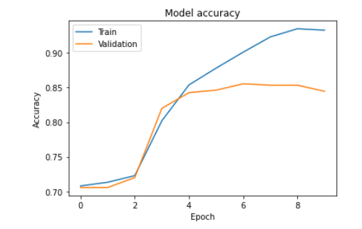

The figure depicts the testing and validation accuracy of the model though different epoch. This result revealed good starting performance, and we will try to enhance results with LSTM or GRU models to represent word sequences in sentences as well as pre-trained models to consider words in context.